Customer Segmentation for E-Commerce Report
Submitted by
Name Yojana More
Course name – data science with python

1. Introduction
Customer segmentation is the process of dividing customers into different groups based on purchasing behavior, demographics, and spending habits. Businesses use customer segmentation to better understand their customers and provide personalized services.
In this project, Machine Learning techniques such as K-Means Clustering and Principal Component Analysis (PCA) are used to identify different customer groups. The project also includes Exploratory Data Analysis (EDA), SQL queries, and visualization using Python libraries.

2. Objective
The objectives of this project are:
- Analyze customer purchasing behavior.
- Clean and preprocess the dataset.
- Perform Exploratory Data Analysis (EDA).
- Reduce data dimensions using PCA.
- Segment customers using K-Means Clustering.
- Visualize customer clusters.
- Generate business insights for targeted marketing.

3 Methodology
The methodology adopted in this project consists of the following steps:
- 1. Dataset Collection
- The E-Commerce Customer Behavior Dataset was collected from Kaggle. It contains customer information such as age, gender, income, purchase frequency, spending score, and product category.
- 2. Data Preprocessing
- The dataset was cleaned by handling missing values, removing duplicate records, encoding categorical variables, and standardizing numerical features to improve data quality.
- 3. Exploratory Data Analysis (EDA)
- EDA was performed to understand customer behavior using statistical analysis and visualizations such as histograms, box plots, scatter plots, and correlation heatmaps.
- 4. Feature Selection and Scaling
- Relevant features related to customer purchasing behavior were selected, and feature scaling was applied using StandardScaler to ensure all variables were on the same scale.
- 5. Principal Component Analysis (PCA)
- PCA was used to reduce the dimensionality of the dataset while retaining the most important information, making clustering more efficient and easier to visualize.
- 6. Customer Segmentation using K-Means
- The K-Means Clustering algorithm was applied to group customers with similar purchasing patterns. The optimal number of clusters was determined using the Elbow Method.
- 7. Visualization and Business Insights
- The generated customer clusters were visualized using PCA scatter plots and other charts. Based on the clusters, business insights were derived to support personalized marketing strategies and improve customer engagement

8.Dataset Link
- Since you used the E-commerce Customer Behavior Dataset, you can mention either your local dataset or the original source.
- Kaggle Dataset:
- https://www.kaggle.com/datasets/uom190346a/e-commerce-customer-behavior-dataset
- Alternative:
- https://www.kaggle.com/

Flowchart
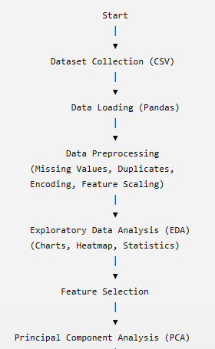

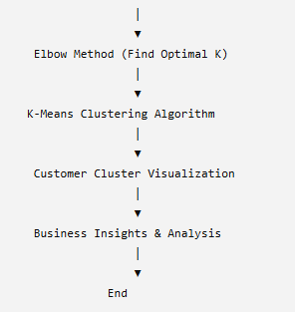

4. Tools and Technologies
Tool | Purpose
Python | Programming Language
Jupyter Notebook | Development Environment
Pandas | Data Manipulation
NumPy | Numerical Computation
Matplotlib | Data Visualization
Seaborn | Statistical Visualization
Scikit-learn | Machine Learning
SQL | Data Analysis
PCA | Dimensionality Reduction
K-Means | Customer Segmentation

5 code and implemention details
1:Import libraries
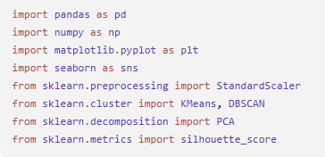
The required libraries are imported for data manipulation, visualization, preprocessing, clustering, dimensionality reduction, and model evaluation
2: Load Dataset
The customer behavior dataset is loaded into a Pandas DataFrame
3: Data Inspection
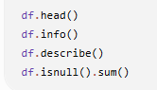
These functions display:
- First five records
- Dataset information
- Statistical summary
- Missing values
4: Data Cleaning
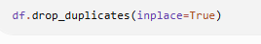
Duplicate records are removed to improve data quality and avoid biased clustering results
5: Exploratory Data Analysis (EDA)
The following visualizations are generated:
- Gender Distribution
- Membership Type Distribution
- Customers by City
- Discount Applied Distribution
- Correlation Heatmap
Purpose
EDA helps understand customer demographics, spending patterns, and relationships among variables.
6: Feature Selection
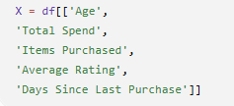
The most relevant numerical features are selected for customer segmentation
7: Feature Scaling
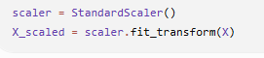
8: Elbow Method
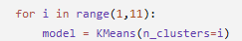
The Elbow Method is used to determine the optimal number of clusters by analyzing the WCSS values
9: K-Means Clustering
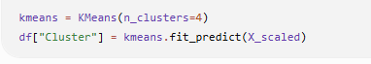
The K-Means algorithm divides customers into four distinct groups based on similar characteristics
10: Silhouette Score
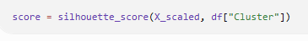
The Silhouette Score evaluates the quality of clustering by measuring how well each customer fits within its assigned cluster.
11:Principal Component Analysis (PCA)
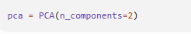
PCA reduces the dataset into two principal components, making it easier to visualize customer clusters.
12: DBSCAN Clustering
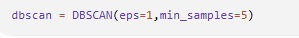
DBSCAN is applied to compare clustering results with K-Means and identify clusters based on density.
13: Cluster Profiling
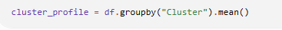
Average values for each cluster are calculated to understand the characteristics of different customer groups.
14: Export Results
The final clustered dataset is exported as a CSV file for further analysis and visualization in Power BI.
6 Result and observation
1: Dataset Successfully Loaded
Observation
- The dataset was successfully imported.
- Customer demographic and purchasing information were available for analysis.
2: Data Cleaning
Observation
- No major missing values were found.
- Duplicate records were removed.
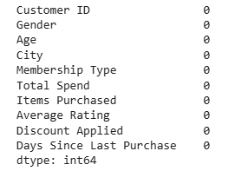
3: Gender Distribution
Observation
- The distribution of male and female customers was visualized.
- This helps understand customer demographics.
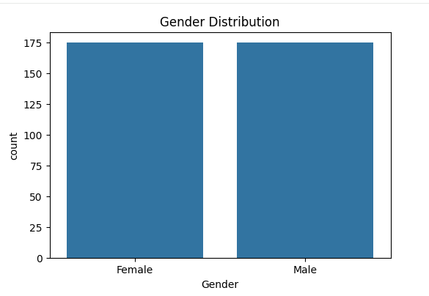
4: Membership Type Analysis
Observation
- Premium members contributed more to customer spending.
- Membership distribution helps identify loyal customer segments.
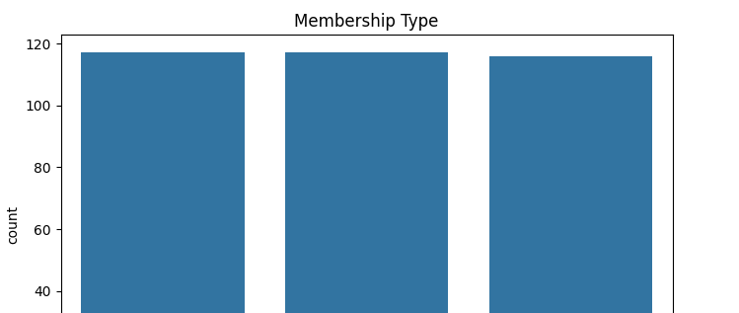
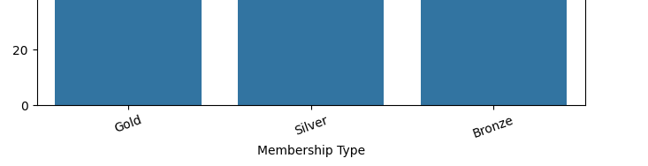
5: City-wise Customer Distribution
Observation
- Customer distribution varied across cities.
- Some cities had significantly more customers.
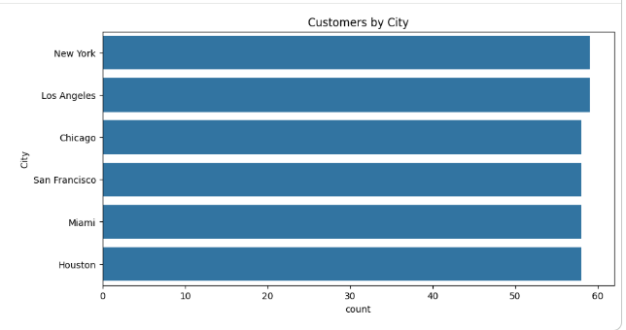
6: Correlation Heatmap
Observation
- Total Spend positively correlated with Items Purchased.
- Average Rating showed a moderate relationship with spending.
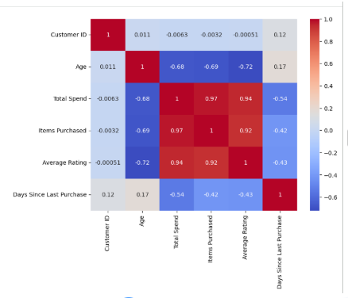
7: Elbow Method
Observation
- The optimal number of clusters was identified as 4.
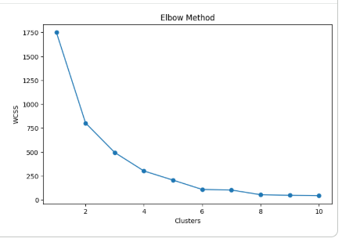
8: K-Means Clustering
Observation
The algorithm grouped customers into four meaningful clusters.
Cluster | Description
Cluster 0 | High Spending Customers
Cluster 1 | Regular Customers
Cluster 2 | Budget Customers
Cluster 3 | New Customers
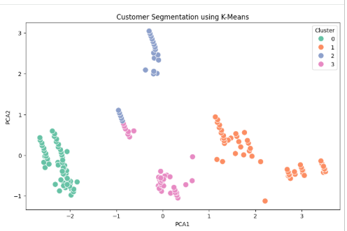
9: DBSCAN Clustering
Observation
DBSCAN identified dense customer groups and detected possible outliers.
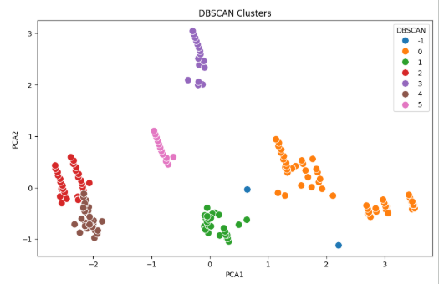
10: Cluster Profile
Observation
Cluster profiling showed differences in:
- Average Spending
- Purchase Frequency
- Customer Ratings
- Days Since Last Purchase
This information helps businesses design targeted marketing strategies.
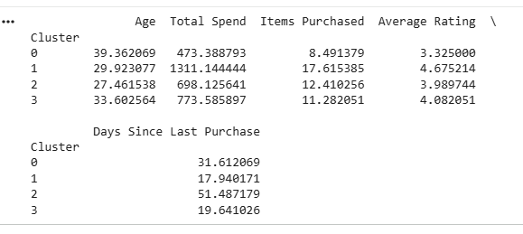

7 Conclusion
The Customer Segmentation for E-Commerce project was successfully implemented using data analytics and machine learning techniques. The project analyzed customer purchasing behavior by performing data preprocessing, exploratory data analysis (EDA), feature scaling, Principal Component Analysis (PCA), and clustering using K-Means and DBSCAN algorithms.
The K-Means algorithm effectively segmented customers into meaningful groups based on features such as Age, Total Spend, Items Purchased, Average Rating, and Days Since Last Purchase. The Elbow Method was used to determine the optimal number of clusters, while the Silhouette Score evaluated the quality of the clustering results. PCA reduced the dataset to two dimensions, making it easier to visualize and interpret the customer segments.
The analysis revealed distinct customer groups, including high-value customers, regular customers, budget-conscious customers, and new or inactive customers. These segments provide valuable insights that can help e-commerce businesses design targeted marketing campaigns, improve customer retention, personalize product recommendations, and optimize promotional offers.

